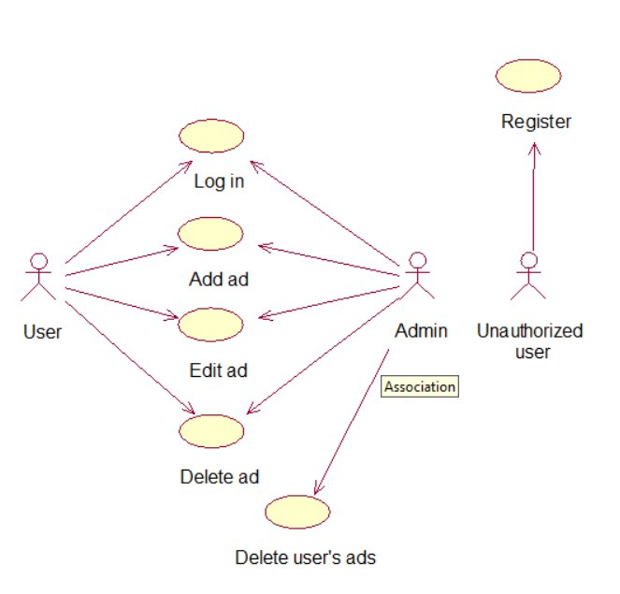

**Events flow for the precedent “Log in”**

Short description

This event calls, when user wants to log in the system.

Main events flow

1. Open website.
2. Click button "Log in".
3. Fill all needed fields.
4. Click "Submit” button.

Post conditions

No.

**Events flow for the precedent “Register”**

Short description

This event calls, when user wants to register in the system.

Main events flow

1. Open website.
2. Click button "Register".
3. Fill all needed fields.
4. Click "Submit” button.

Post conditions

New user added to database.

**Events flow for the precedent “Add ad”**

Short description

This event calls, when user wants to add new ad in the system.

Main events flow

1. Click button "My Profile" and open profile.
2. Click button "Create ad".
3. Fill all fields and click "Add".

Post conditions

New ad added to the database.

**Events flow for the precedent “Edit ad”**

Short description

This event calls, when user wants to edit some ad.

Main events flow

1. Click button "My Profile" and open profile.
2. Choose needed ad and open it.
3. Click button "Edit ad".
4. Edit needed fields and click "Confirm".

Post conditions

Some ad updated in the database.

**Events flow for the precedent “Delete ad”**

Short description

This event calls, when user wants to delete some ad.

Main events flow

1. Click button "My Profile" and open profile.
2. Choose needed ad and open it.
3. Click button "Delete ad".
4. Confirm your action.

Post conditions

Some ad deleted from the database.

**Events flow for the precedent “Delete user's ad”**

Short description

This event calls, when admins wants to delete some user’s ad.

Main events flow

1. Open needed user's profile.
2. Choose needed ad and open it.
3. Click button "Delete ad".
4. Confirm your action.

Post conditions

Some ad deleted from the database.